**LAB 12**

**Ansible Commands and Playbooks**

**Repeat the steps in Experiment 11 to create the initial setup**

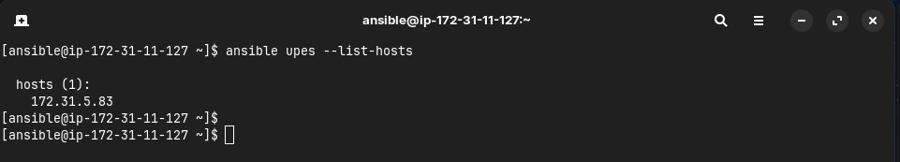**STEP 1: Check list of hosts.**

**STEP 2: Install Apache server on node server using adhoc command.**

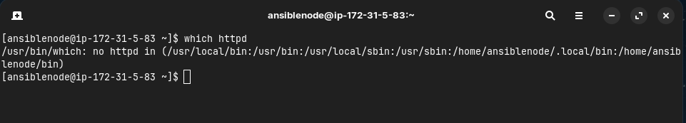

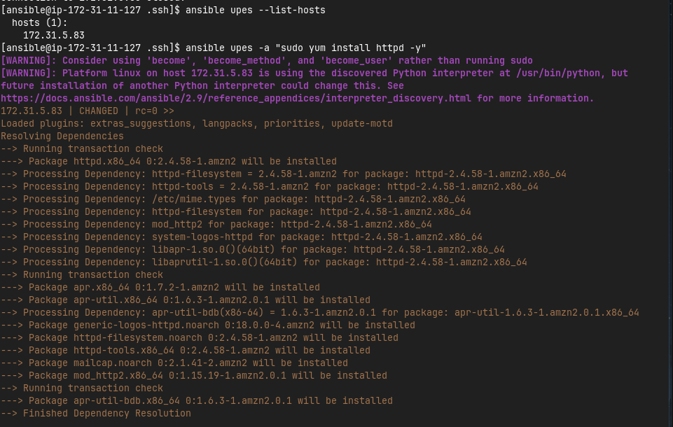

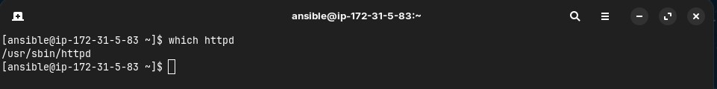

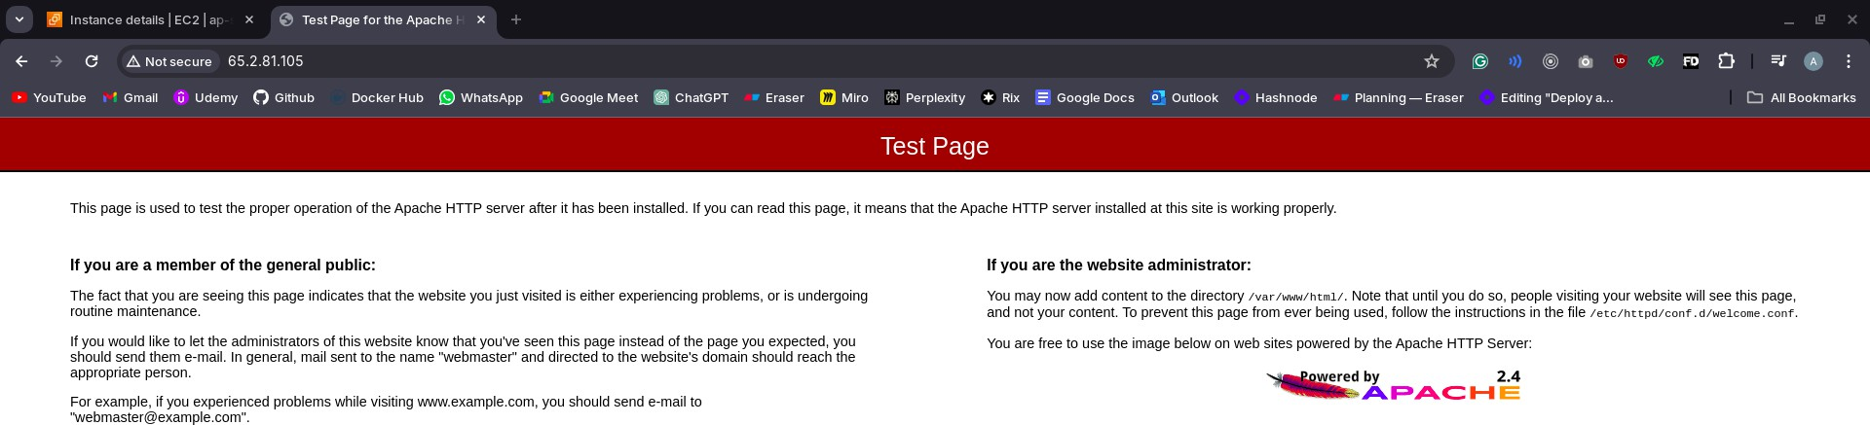**STEP 3: Start the httpd service using ansible.**

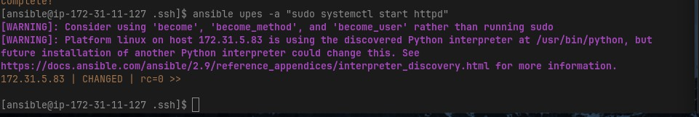

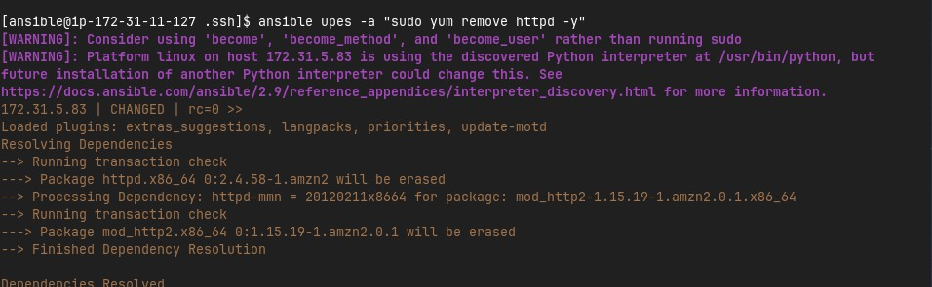**STEP 4: Remove ansible and then reinstall using ansible playbook.**

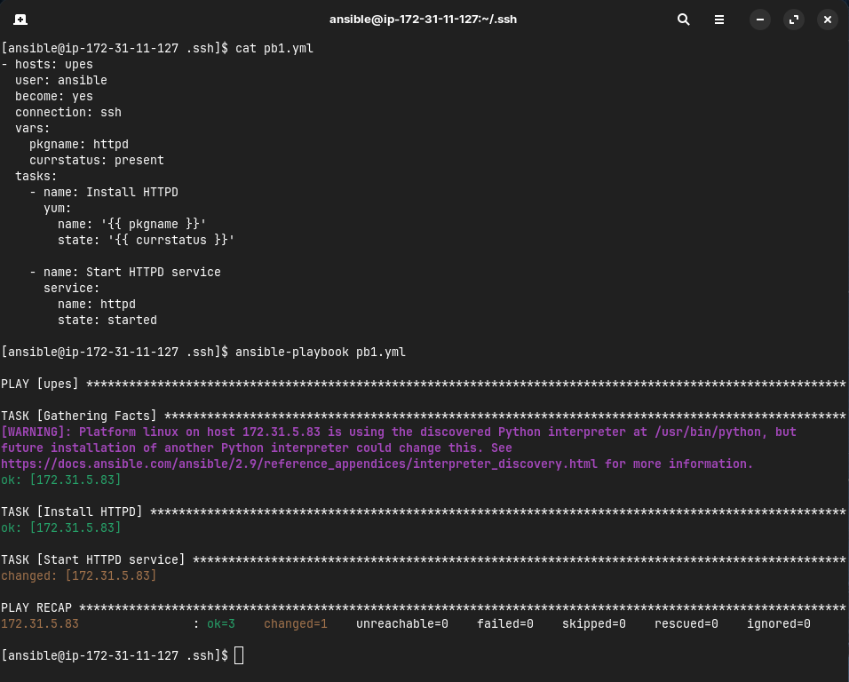



**STEP 5: Testing other playbooks.**

